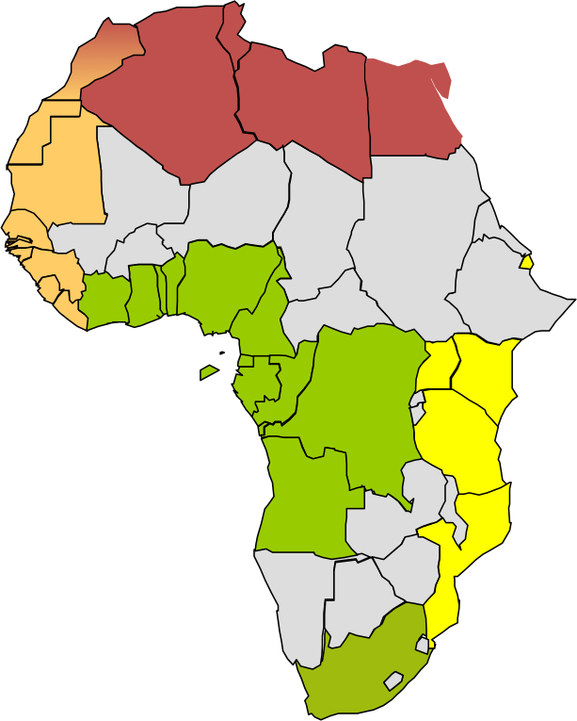

**Cote d’Ivoire**

**Ghana**

**Togo**

**Benin**

**Nigeria**

**Cameroon**

**Equatorial Guinea**

**Gabon**

**Angola**

**Senegal**

**STP**

Interregional Coordination Center

Regional MOC

Multinational MOC

National MOC/Focal Point

**Congo**

**DRC**

Zone G

Zone F

Zone E

Zone D

Zone A

**Guinea**

**Sierra Leone**

**Liberia**

