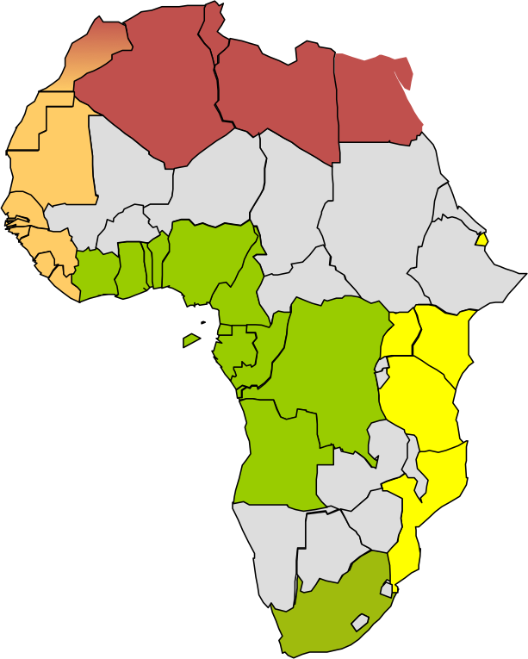
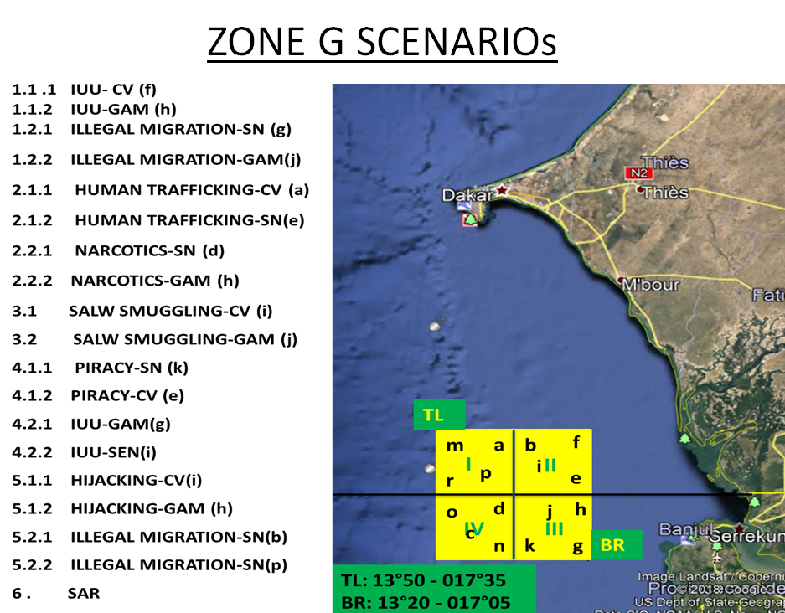
Cote d’Ivoire
Ghana
Togo
Benin
Nigeria
Cameroon
Equatorial Guinea
Gabon
Angola
Senegal
STP
Interregional Coordination Center
Regional MOC
Multinational MOC
National MOC/Focal Point
Congo
DRC
Zone G
Zone F
Zone E
Zone D
Zone A
Guinea
Sierra Leone
Liberia

